# Q 7 answer

# YOLO Model Box Filtering Explanation

## Introduction to YOLO and the Context of the Code

In this section of the lab, we examine the output of a YOLO (You Only Look Once) model, particularly focusing on the filtering of bounding boxes based on confidence scores and class probabilities. The given code snippet demonstrates how TensorFlow is used to process and filter these boxes in a typical object detection setup.

## Explanation of the 1783 Boxes

The YOLO model generates bounding boxes across a grid from an image, each with associated object confidence scores and class probabilities. In the code provided, each of the 19x19 cells on the grid produces 5 bounding boxes, resulting in a total of 19 x 19 x 5 = 1805 initial boxes. These boxes are then filtered by the yolo_filter_boxes function, which calculates a combined score by multiplying the box confidence by the highest class probability for each box. Only those boxes with a combined score above a threshold of 0.5 are retained. The resulting 1783 boxes indicate that 22 boxes had combined scores below this threshold and were therefore discarded.

## Maximum and Minimum Number of Boxes

Maximum Number: The maximum number of boxes that could pass the filter is 1805, which is the initial number of boxes generated. This scenario would occur if all boxes have combined scores above the threshold.

Minimum Number: The minimum number of boxes can be zero. This would happen if all boxes have combined scores below the threshold, leading to all boxes being filtered out.

# Q 8 answer

# Understanding Anchor Boxes in YOLO

## Advantages of Using Anchor Boxes

Anchor boxes allow the model to detect objects of various shapes and sizes by predefining potential bounding boxes of multiple scales and aspect ratios. This approach helps in improving the detection accuracy, especially for images with multiple objects of different sizes, and reduces the complexity of the model by minimizing the need for the network to learn to predict size and aspect ratio for each object independently.

## Method Used to Determine the Sizes of Anchor Boxes

The sizes of anchor boxes are usually determined through a clustering approach on the training dataset, typically using k-means clustering. This method involves clustering ground truth bounding boxes to optimize for width and height by minimizing the Intersection over Union (IoU) loss, rather than traditional Euclidean distance. The number of clusters, k, is a tunable hyperparameter that depends on the diversity of object sizes in the dataset.

# Q 10 answer

# Observations for Autonomous Driving Dataset Images

## Image 0104 Observations

* Correctly Detected Objects: Traffic Light, Truck
* Incorrectly Detected Objects: there is no incorrect detection
* Undetected Objects: other traffic lights, long-distance car and bicycle
* Incorrect Bounding Boxes: there is no incorrect bounding boxes

## Image 0116 Observations

* Correctly Detected Objects: car, traffic light
* Incorrectly Detected Objects: there is no incorrect detection
* Undetected Objects: : other traffic lights, one truck and other long-distance cars
* Incorrect Bounding Boxes there is no incorrect bounding boxes

# Q 11 answer

# Adjusting parameters of yolo_eval function

## Adjusting max_boxes Parameter

Upon adjusting the max_boxes parameter in the YOLO model's evaluation settings, there were no changes observed in the output for the autonomous driving dataset images. This indicates that the original setting for max_boxes was likely sufficient, and the limit was not a constraining factor in the detection results.

## Adjustment of the Score Threshold

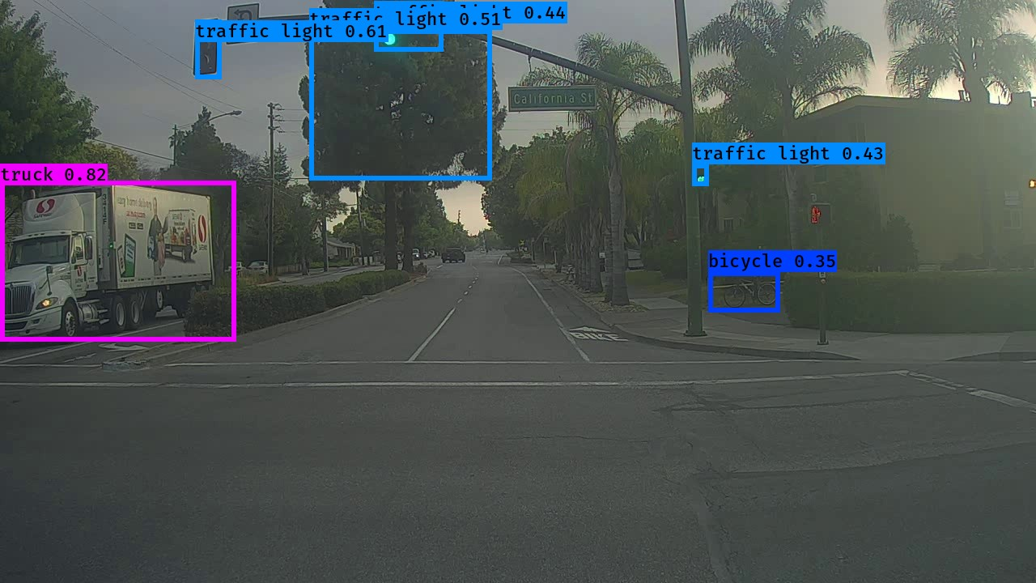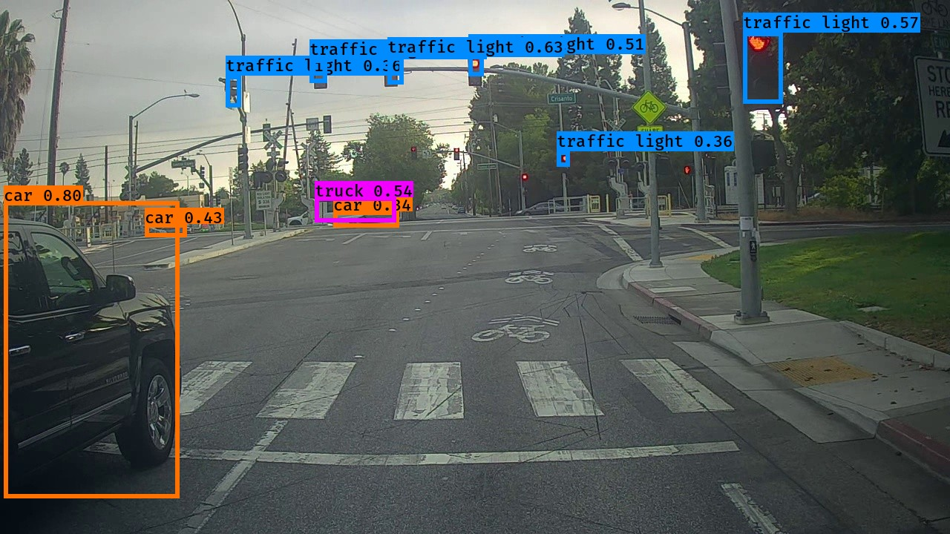In an effort to refine object detection capabilities, the score_threshold was adjusted from 0.6 to 0.3, while maintaining the original values for max_boxes and iou_threshold. This adjustment led to a noticeable improvement in the detection accuracy, as the model was able to identify additional object classes that were not detected with the higher threshold. This suggests that the original threshold was potentially too restrictive, omitting valid detections. The newly detected objects with the lowered threshold demonstrate the model’s enhanced ability to recognize and classify a wider range of objects within the autonomous drivingdataset.

## Adjustment of the IOU Threshold

The iou_threshold was modified to explore its impact on object detection within the autonomous driving dataset, while max_boxes and score_threshold were kept at their original settings. Despite the change in the iou_threshold value, no differences were observed in the detection outputs. This indicates that the original IoU setting was already appropriate for the current detection tasks, or that the dataset characteristics and object placements do not heavily influence IoU threshold sensitivity in this particular model configuration.